MediVault

A Project Report

Submitted by

Boddu Alekhya Mahathi – 23BSA10051
Yug Kochar – 23BSA10089
Kanishka Agrawal – 23BSA10095
Kushal Jain – 23BSA10145
Shreena Mani – 23BSA10066

in partial fulfilment for the award of the degree
of
BATCHELOR OF TECHNOLOGY
In
COMPUTER SCIENCE AND ENGINEERING(Cloud Computing and Automation)


SCHOOL OF COMPUTER SCIENCE AND ENGINEEING
VIT BHOPAL UNIVERSITY
KOTHRIKALAN, SEHORE
MADHYA PRADESH – 466114

December 2024
VIT BHOPAL UNIVERSITY, KOTHRIKALAN, SEHORE
MADHYA PRADESH – 466114

BONAFIDE CERTIFICATE

Certified that this project report titled “MediVault” is the bonafide work of Yug Kochar (23BSA10089), Boddu Alekhya Mahathi(23BSA10051), Kaniska Agrawal(23BSA10095), Kushal Jain(23BSA10145), Shreena Mani(23BSA10066) who carried out the project work under my supervision. Certified further that to the best of my knowledge the work reported at this time does not form part of any other project/research work based on which a degree or award was conferred on an earlier occasion on this or any other candidate.

PROGRAM CHAIR, PROJECT GUIDE,
Dr. Virender Singh Kushwah Dr. C.P. Koushik
Senior Assistant Professor, School of Assistant Professor Grade 1, School
Computing Science Engineering and of Computer Science Engineering
Artificial Intelligence (SCAI) and Artificial Intelligence (SCAI)
VIT BHOPAL UNIVERSITY VIT BHOPAL UNIVERSITY

The Project Exhibition I Examination is held on _______________
ACKNOWLEDGEMENT

First and foremost I would like to thank the Lord Almighty for His presence and immense blessings throughout the project work.
I wish to express my heartfelt gratitude to Dr Virendra Singh Kushwah, Program Chair, Cloud Computing and Automation, for much of his valuable support and encouragement in carrying out this work.
I would like to thank my internal guide Dr. C.P. Koushik, for continually guiding and actively participating in my project, giving valuable suggestions to complete the project work.
I would like to thank all the technical and teaching staff of the School Computing Science and Engineering, who extended directly or indirectly all support.
Last, but not least, I am deeply indebted to my parents who have been the greatest support while I worked day and night for the project to make it a success.

ABSTRACT

Healthcare facilities like hospitals and clinics require efficient inventory management systems to ensure the availability of essential medicines and supplies. "MediVault" is a comprehensive, web-based inventory management system specifically designed to streamline the management of medical supplies in healthcare institutions. The system provides a user-friendly interface for managing the lifecycle of medicines, from procurement to dispensing, while maintaining accurate records and ensuring regulatory compliance.

The project features secure employee login/logout functionality to ensure data confidentiality and role-based access. It offers robust medicine management capabilities, allowing users to add, update, and track medicine stocks. Key features include automated notifications for low stock levels, expired medicines, and upcoming restocking requirements, ensuring that critical supplies are always available. MediVault incorporates an SQL-based database for efficient storage and retrieval of information related to medicines, employees, manufacturers, and billing records.

The frontend of the system is built using HTML, CSS, and JavaScript, providing an intuitive and responsive user interface. Java is utilized for the backend to handle complex business logic, integrate with the database, and ensure seamless operations. Advanced features such as dynamic search, customizable reports, and secure transaction logging further enhance the system's utility.

MediVault aims to improve operational efficiency, reduce manual errors, and support healthcare facilities in delivering uninterrupted patient care. By leveraging modern web technologies and prioritizing usability, this system provides a scalable and reliable solution for medical inventory management in healthcare environments.

LIST OF FIGURES AND GRAPHS
Figure No. | TITLE | PAGE NO.
1 | System Architecture Diagram | 6
2.1 | Login page | 11
2.2 | Dashboard | 12
2.3 | Buy-meds page | 12
2.4.1 | Database before buying | 13
2.4.2 | Buying medicine Code output | 13
2.4.3 | Database after buying | 13
2.5.1 | Email sent output | 14
2.5.2 | Screenshot of received email | 14
2.6.1 | Database before restocking | 15
2.6.2 | Restocking code executed successfully | 15
2.6.3 | Database after restocking | 15
3.1 | Login page code | 17
3.2 | Dashboard page code | 18
3.3.1 | Buy-meds page code -1 | 18
3.3.2 | Buy-meds page code-2 | 19
3.3.3 | Buy-meds page code-3 | 19
3.4.1 | Cart page code-1 | 20
3.4.2 | Cart page code-2 | 20
3.5.1 | JavaScript code for web page functionality-1 | 21
3.5.2 | JavaScript code for web page functionality-2 | 21
3.5.3 | JavaScript code for web page functionality-3 | 22
3.6 | Restocking functionality code | 22
3.7.1 | Email sending functionality-1 | 23
3.7.2 | Email sending functionality-2 | 23
3.7.3 | Email sending functionality-3 | 24

TABLE OF CONTENTS
Chapter No | Title | Page No
1. | PROJECT DESCRIPTION AND OUTLINE | 1
 | 1.1 INTRODUCTION | 1
 | 1.2 MOTIVATION OF THE WORK | 1
 | 1.3 INTRODUCTION TO PROJECT | 1
 | 1.4 PROBLEM STATEMENT | 1
 | 1.5 OBJECTIVE OF THE WORK | 1
 | 1.6 ORGANIZATION OF THE WORK | 2
2 | RELATED WORK INVESTIGATION | 3
 | 2.1 EXISTING APPROACH | 3
 | 2.2 PROS AND CONS | 3
 | 2.3 ISSUES FROM INVESTIGATION | 3
3 | REQUIREMENT ARTIFACTS | 4
 | 3.1 HARDWARE AND SOFTWARE REQUIREMENT | 4
 | 3.2 SPECIFIC PROJECT REQUIREMENT | 4
 | 3.2.1 DATA REQUIREMENT | 4
 | 3.2.2 FUNCTIONAL REQUIREMENT | 4
 | 3.2.3 PERFORMANCE AND SECURITY REQUIREMENT | 5
 | 3.2.4 LOOK AND FEEL REQUIREMENT | 5
4 | DESIGN METHODOLOGY AND ITS NOVELTY | 6
 | 4.1 SYSTEM ARCHITECTURE | 6
 | 4.2 SUBSYSTEM SERVICES | 7
5 | TECHNICAL IMPLEMENTATION | 10
 | CODING AND CODE SOLUTION | 10
 | TESTING AND VALIDATION | 10
 | PERFORMANCE ANALYSIS | 10
6 | PROJECT OUTCOME | 11
7 | CONCLUSION AND FUTURE ENHANCEMENT | 16
 | APPENDIX - 1 | 17
 | APPENDIX - 2 | 25
 | REFERENCE | 25

CHAPTER 1:
PROJECT DESCRIPTION AND OUTLINE

1.1 INTRODUCTION
MediVault is an inventory management system designed for pharmacies. It facilitates efficient stock management, employee directory maintenance, and ensures the timely availability of medicines by automating inventory tracking and restocking alerts.

1.2 MOTIVATION OF THE WORK
Pharmacies face challenges like overstocking, shortages, and manual errors in inventory management. MediVault addresses these issues by automating and streamlining the inventory management process.

1.3 INTRODUCTION TO PROJECT
MediVault features:
- Real-time inventory tracking.
- Automated alerts for low stock and expired medicines.
- Employee management directory.
- Comprehensive reporting and analytics.

1.4 PROBLEM STATEMENT
Manual inventory systems are prone to human errors and inefficiencies. A streamlined, automated solution like MediVault improves accuracy, reduces wastage, and ensures the availability of essential medicines.

1.5 OBJECTIVE OF THE WORK
The goal of MediVault is to design a scalable, reliable inventory and employee management system that ensures efficient operation in pharmacy environments.

1.6 ORGANIZATION OF THE WORK
This report comprises seven chapters outlining the project background, related work, requirements, design, implementation, outcomes, and future scope.

CHAPTER 2:
RELATED WORK INVESTIGATION

2.1 EXISTING APPROACH
Current pharmacy management systems rely on manual or semi-automated methods that lack scalability, accuracy, and alert mechanisms.

2.2 PROS AND CONS
Existing systems:
- Pros: Familiarity and simplicity.
- Cons: Prone to errors, lack of automation, and reactive (rather than proactive) inventory management.

2.3 ISSUES FROM INVESTIGATION
- Difficulty in maintaining up-to-date stock records.
- Manual methods are time-consuming and error-prone.
- Limited functionality in notifying about low stock or expired items.

CHAPTER 3:
REQUIREMENT ARTIFACTS

3.1 HARDWARE AND SOFTWARE REQUIREMENTS
- Hardware:
  - Processor: Intel i5 or above.
  - RAM: 8GB or above.
- Software:
  - Frontend: HTML, CSS, JavaScript.
  - Backend: Java.
  - Database: MySQL.
3.2 SPECIFIC PROJECT REQUIREMENTS
3.2.1 DATA REQUIREMENT
- Medicine inventory data.
- Employee records.
- Manufacturer details.
3.2.2 FUNCTIONAL REQUIREMENT
- Stock tracking.
- Automated email notifications.
- Employee login/logout system.
3.2.3 PERFORMANCE AND SECURITY REQUIREMENT
- Real-time performance.
- Secure database with role-based access control.
3.2.4 LOOK AND FEEL REQUIREMENT
- User-friendly interface.
- Clear visual indicators for stock levels.
- Responsive design.

CHAPTER 4:
DESIGN METHODOLOGY AND ITS NOVELTY

4.1 SYSTEM ARCHITECTURE
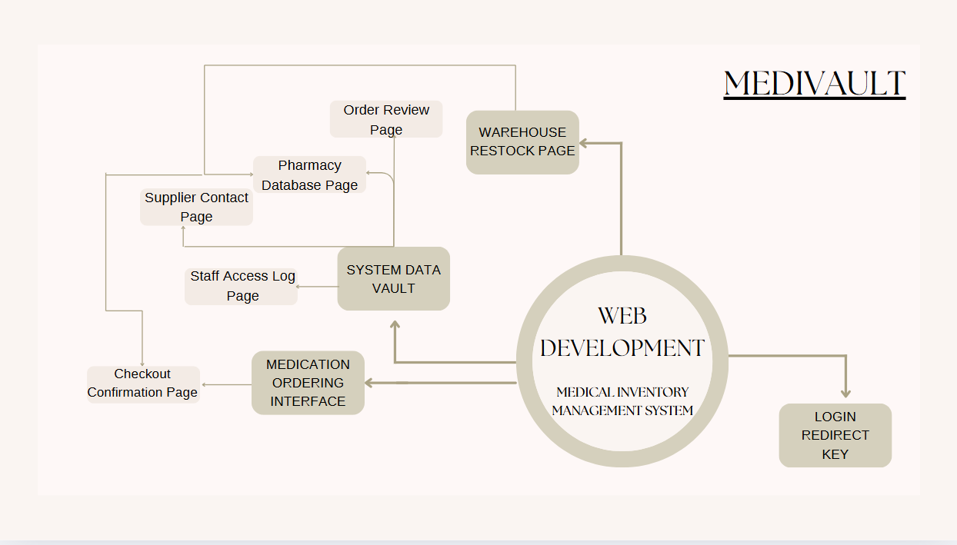
Figure 1 – System Architecture Diagram

4.2 SUBSYSTEM SERVICES

Inventory Management.

Employee Directory Management.

Automated Alert System.
Objective
The primary objective of the MediVault project is to design and implement a robust inventory management system tailored for pharmacies to streamline operations, reduce errors, and ensure the timely availability of essential medicines. The system aims to:
- Automate Inventory Management: Provide real-time tracking of stock levels, automatically deduct sold items, and notify users of low stock or expired medicines.
- Enhance Operational Efficiency: Minimize human errors in stock tracking and restocking, thereby improving overall pharmacy operations.
- Improve Decision-Making: Offer detailed reports and analytics to help pharmacy managers make informed decisions about inventory and procurement.
- Ensure User Accessibility and Security: Provide a user-friendly interface with secure login/logout functionality for employees to manage inventory and access records efficiently.

Methodology
The development of MediVault follows a systematic approach encompassing the following stages:
1. Problem Analysis and Requirements Gathering
- Understanding Challenges: Analyze the limitations of existing manual or semi-automated inventory management systems in pharmacies.
- System Requirements: Define hardware, software, functional, and non-functional requirements to guide the development process.
2. System Design
- System Architecture:
  - Design a three-tier architecture comprising the frontend, backend, and database layers.
  - Ensure modular design for scalability and ease of maintenance.
- Database Design:
  - Define database schemas for medicines, employees, manufacturers, transactions, and notifications.
  - Incorporate relational tables for efficient query execution and data integrity.
- UI/UX Design:
  - Create wireframes and mockups for the user interface to ensure a simple and intuitive user experience.
  - Include features like inventory dashboards, low-stock alerts, and employee management tools.
3. Development
- Frontend Development:
  - Use HTML, CSS, and JavaScript to build a responsive and interactive user interface.
  - Integrate visual indicators for stock levels and notifications.
- Backend Development:
  - Develop the core application logic using Java.
  - Implement modules for inventory management, employee login/logout, and automated email alerts.
- Database Integration:
  - Use MySQL for database management, ensuring secure storage and retrieval of data.
  - Implement triggers for automated email notifications when stock levels fall below a threshold.
4. Implementation of Features
- Inventory Management:
  - Enable real-time tracking of medicine stock levels.
  - Automatically deduct stock upon sales and update the database.
- Low Stock Notifications:
  - Use SMTP integration to send automated emails when stock levels are low or medicines are near expiry.
5. Testing and Validation
- Unit Testing: Test individual modules (e.g., inventory updates, notification triggers) for correctness.
- Integration Testing: Ensure seamless communication between frontend, backend, and database layers.
- Performance Testing: Evaluate system efficiency under varying load conditions.
- User Testing: Collect feedback from pharmacy staff to refine the interface and functionalities.
6. Deployment and Maintenance
- Deploy the application on a web server, ensuring accessibility within the pharmacy’s network.
- Provide training for pharmacy staff to familiarize them with the system.
- Establish a maintenance plan for regular updates and troubleshooting.

CHAPTER 5 :
TECHNICAL IMPLEMENTATION

- Coding and Code Solutions: Implementation of inventory, alert systems, and employee modules using Java and SQL.

- Testing and Validation: Unit testing, integration testing, and stress testing conducted for all modules.

- Performance Analysis: Results indicate efficiency improvements over manual systems.

CHAPTER 6 :
PROJECT OUTCOME

Output 1 – The Login page
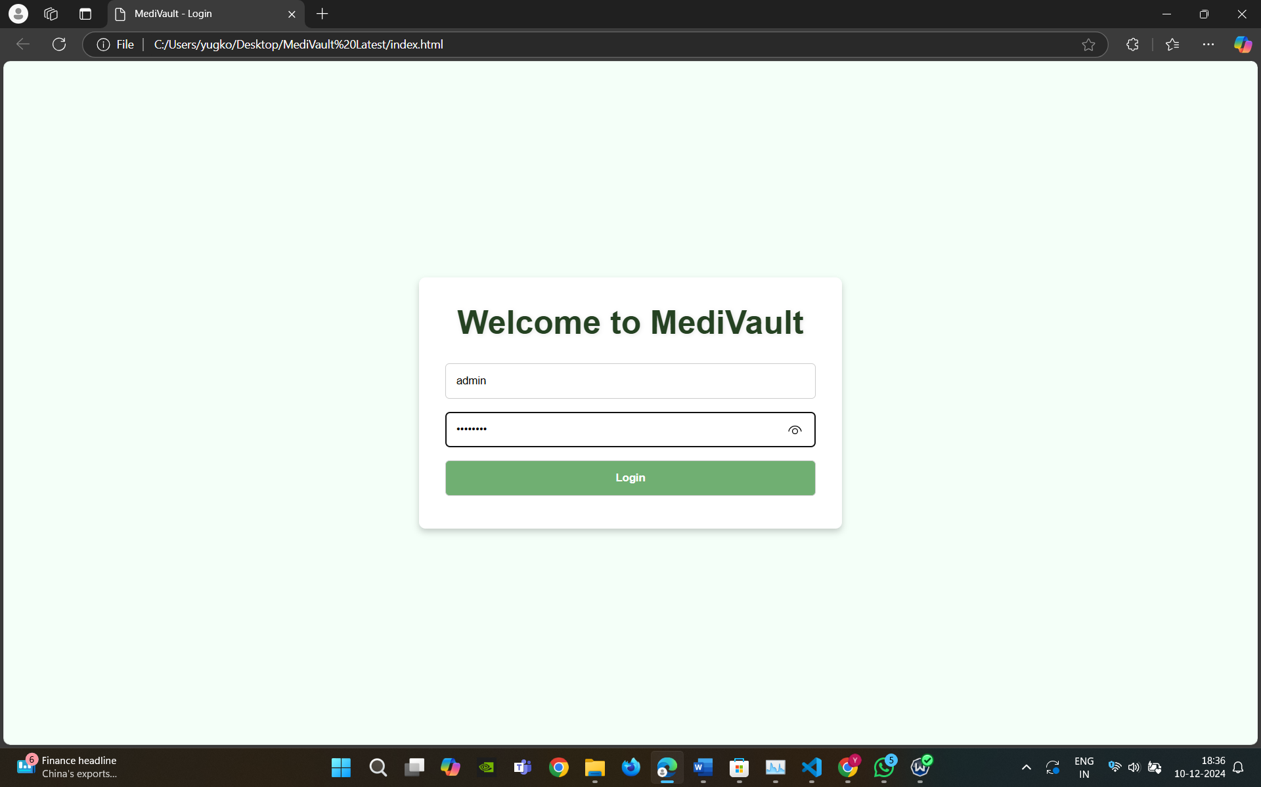
Figure 2.1
Output 2 –The Dashboard
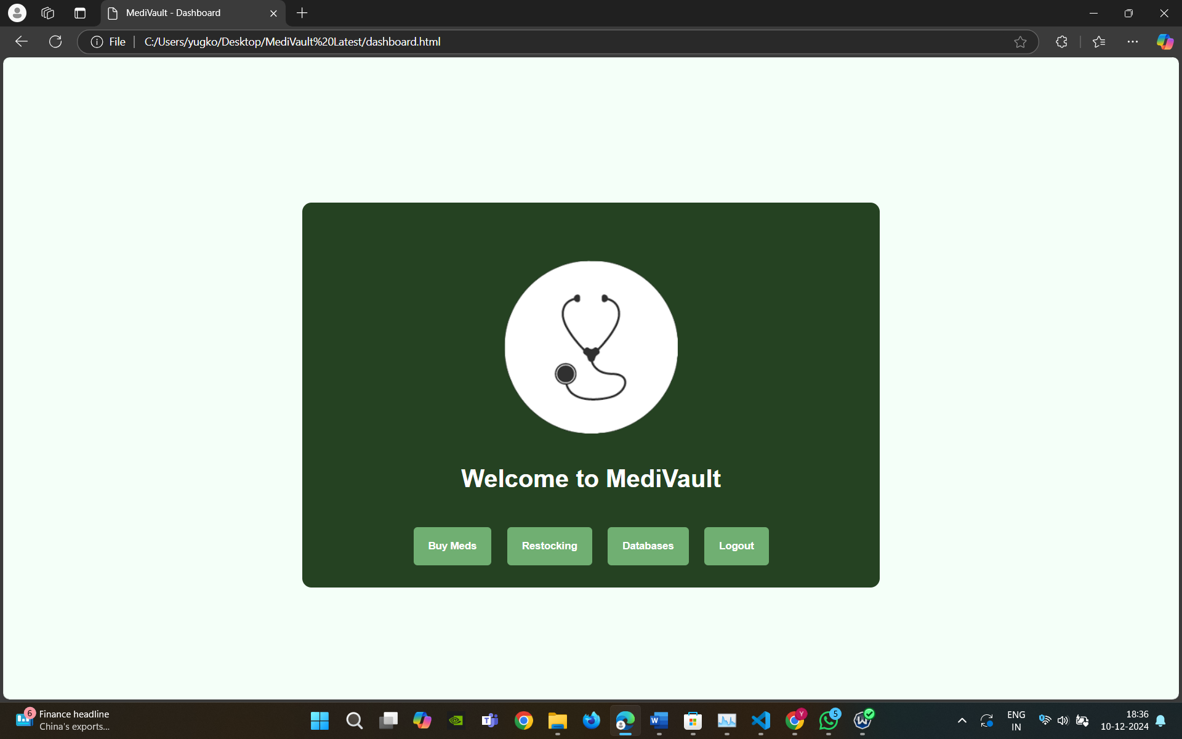

Figure 2.2

Output 3 – The buying medicines page -
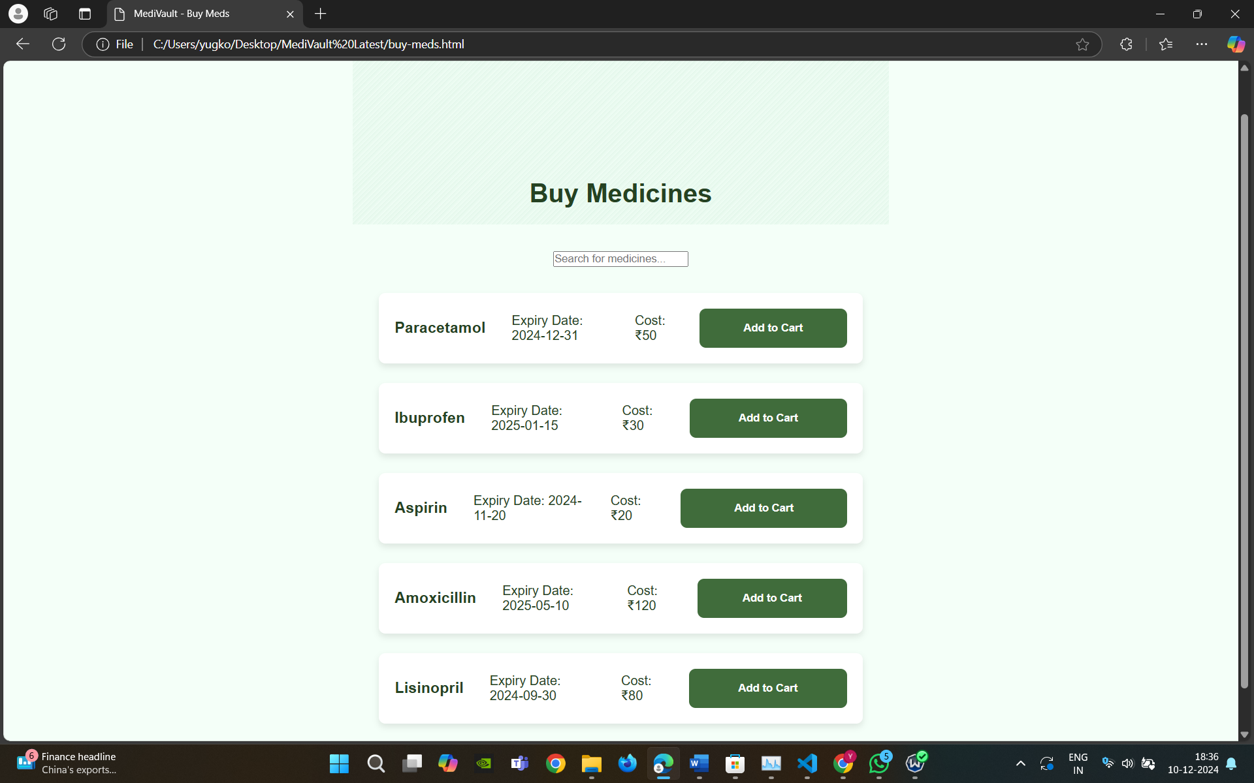
Figure 2.3
Output 4 – The medicine purchase functionality -
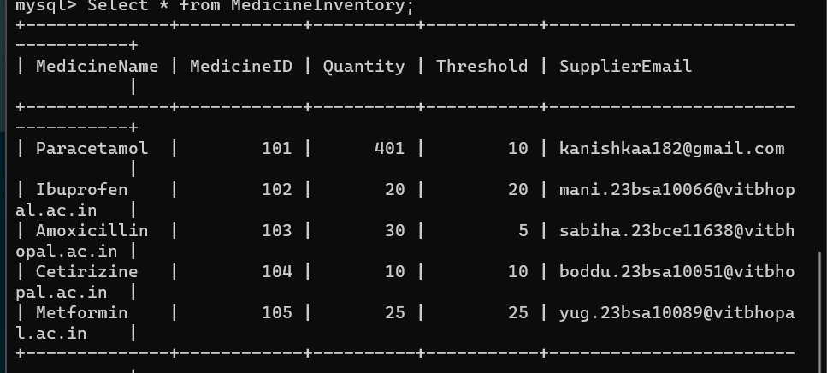
Figure 2.4.1 – Shows the database before the purchase.
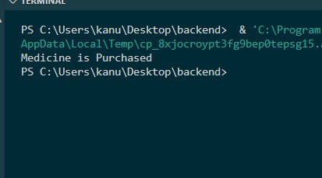
Figure 2.4.2 – Output on running the code.
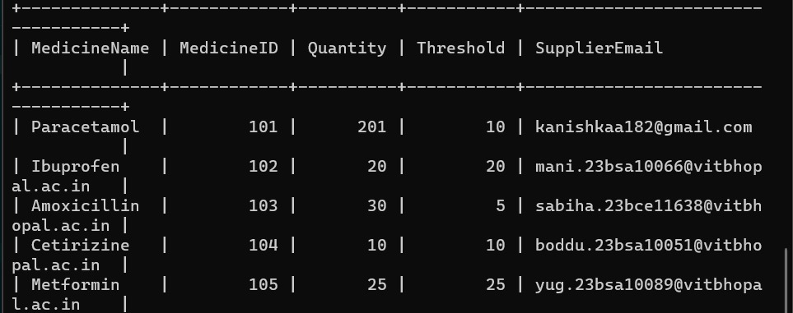
Figure 2.4.3 – Shows the database after the purchase.
Output 5 - The Email to suppliers-
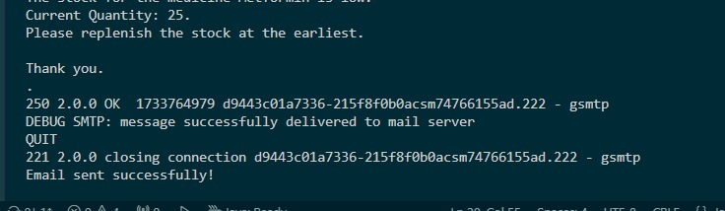
Figure 2.5.1- Output when you run the code.

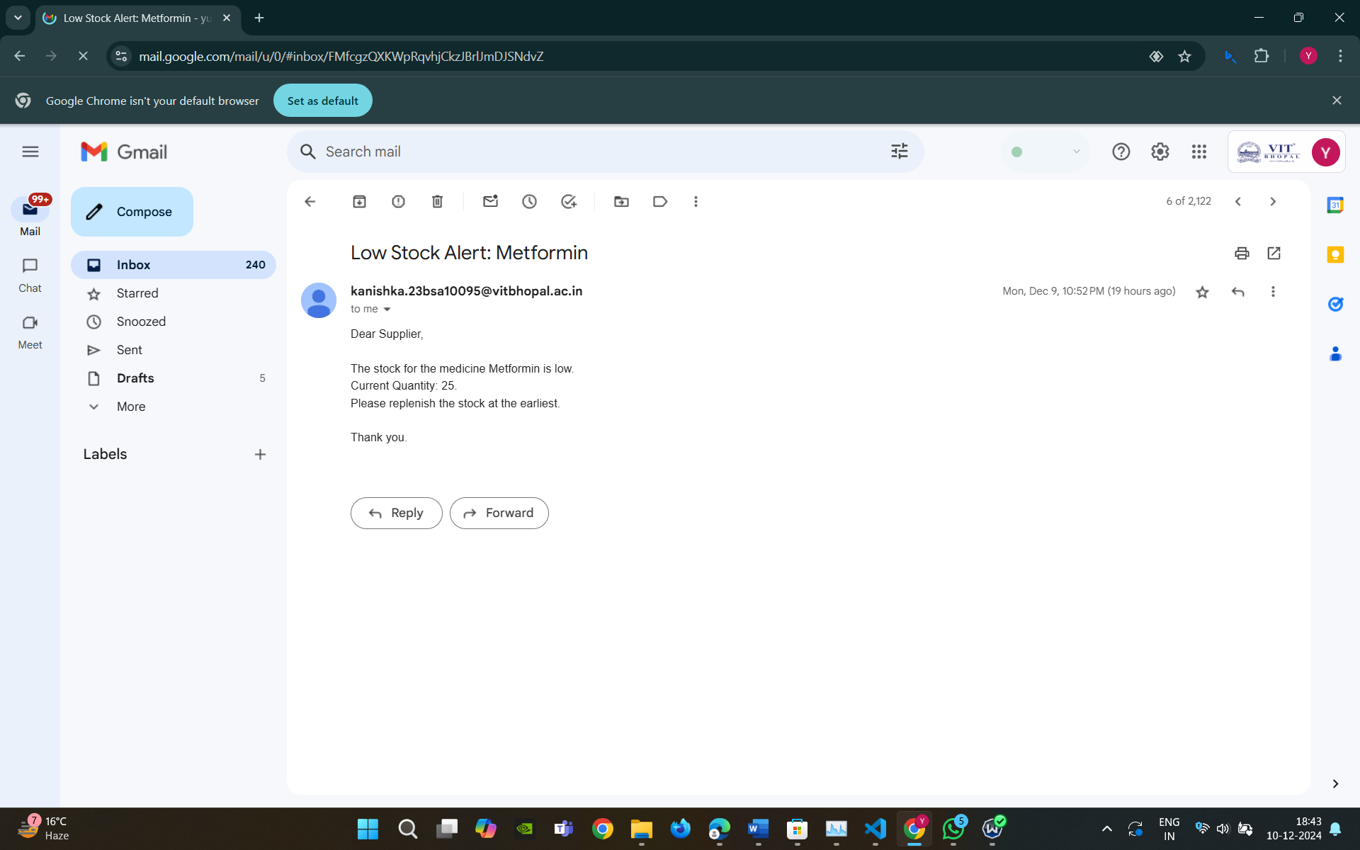
Figure 2.5.2 – Email received when the code is executed successfully

Output 6 - Restocking 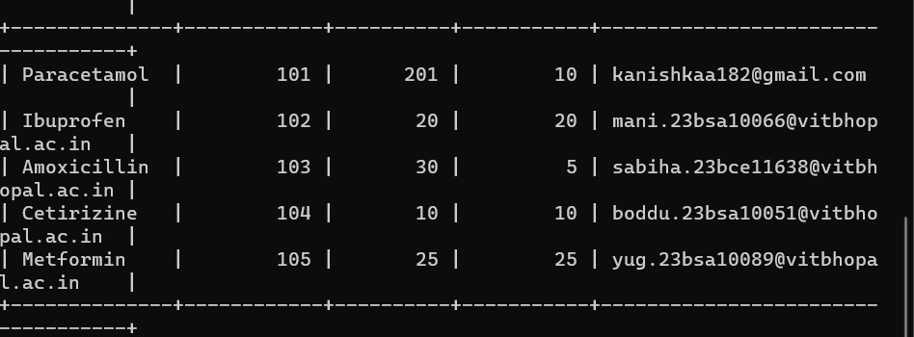
Figure 2.6.1 – Database before the restocking
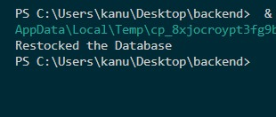
Figure 2.6.2 – Confirmation of execution of code
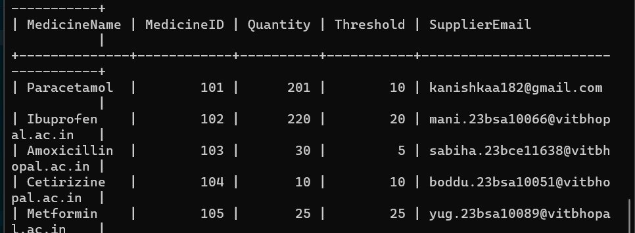
Figure 2.6.3 – Database after the restocking

CHAPTER 7:
CONCLUSION

MediVault addresses the critical need for a reliable and efficient inventory management system in healthcare settings. By automating the management of medical supplies and streamlining workflows, it reduces the burden of manual tracking and minimizes errors that could impact patient care. The system's intuitive interface, robust backend architecture, and data-driven approach ensure that healthcare facilities can maintain optimal inventory levels, prevent medicine expiration, and adhere to regulatory requirements.

Through features such as automated notifications, secure login/logout functionality, and dynamic reporting, MediVault empowers staff to focus on delivering quality care without the constant worry of inventory shortages or mismanagement. Its scalable and adaptable design ensures that it can grow alongside the needs of the healthcare facility, making it a sustainable solution for the long term.

In conclusion, MediVault not only enhances operational efficiency but also contributes to better healthcare outcomes by ensuring that critical medical supplies are always available. It stands as a valuable tool for modernizing inventory management in hospitals and clinics, supporting their mission of delivering reliable and efficient healthcare services.

REFERENCE
[1] - Refonaa, J., SL Jany Shabu, Kg Dion Paul, S. Dhamodaran, and Viji Amutha Mary. "MediStock: Medical Inventory Management System." In 2023 4th International Conference on Electronics and Sustainable Communication Systems (ICESC), pp. 738-743. IEEE, 2023.
[2] - Saha, Esha, and Pradip Kumar Ray. "Patient condition-based medicine inventory management in healthcare systems." IISE Transactions on Healthcare Systems Engineering 9, no. 3 (2019): 299-312.
[3] - Kritchanchai, Duangpun, and Watcharaphong Meesamut. "Developing inventory management in hospital." International Journal of Supply Chain Management 4, no. 2 (2015): 11-19.
[4] - Zakas, Nicholas C. Professional JavaScript for Web Developers. John Wiley & Sons, 2005.
[5] - Zhou, Wei, Li Li, Min Luo, and Wu Chou. "REST API design patterns for SDN northbound API." In 2014 28th international conference on advanced information networking and applications workshops, pp. 358-365. IEEE, 2014.
[6]- Serrano, Diego, Eleni Stroulia, Diana Lau, and Tinny Ng. "Linked REST APIs: a middleware for semantic REST API integration." In 2017 IEEE International Conference on Web Services (ICWS), pp. 138-145. IEEE, 2017.
[7] - Monteiro, Fernando. Hands-On Full Stack Web Development with Angular 6 and Laravel 5: Become fluent in both frontend and backend web development with Docker, Angular and Laravel. Packt Publishing Ltd, 2018.
[8] - Dutta, S., K. Feige, K. Rink, and B. Nsonga. "A Flexible Architecture for Web-based GIS Applications using Docker and Graph Databases." (2024).
[9] - Annanias, Yves, and Daniel Wiegreffe. "A Flexible Architecture for Web-based GIS Applications using Docker and Graph Databases." arXiv preprint arXiv:2404.12074 (2024).
[10] - Choma, Dominik, Kinga Chwaleba, and Mariusz Dzieńkowski. "The efficiency and reliability of backend technologies: Express, Django, and Spring Boot." Informatyka, Automatyka, Pomiary w Gospodarce i Ochronie Środowiska 13 (2023).
[11] - Rajput, Ajeet Singh, Harsh Pratap Singh, Garima Bang, Shelley Joshi, and Trapti Patidar. "Comparing Spring Boot and ReactJS with Other Web Development Frameworks: A Study." In International Conference on Data Science and Applications, pp. 149-160. Singapore: Springer Nature Singapore, 2023.
[14] - Nadon, Jason. Website Hosting and Migration with Amazon Web Services: A Practical Guide to Moving Your Website to AWS. Apress, 2017.
[15]- Sarkar, Aurobindo, and Amit Shah. Learning AWS: Design, build, and deploy responsive applications using AWS Cloud components. Packt Publishing Ltd, 2018.

APPENDIX -1
CODING
Login page –
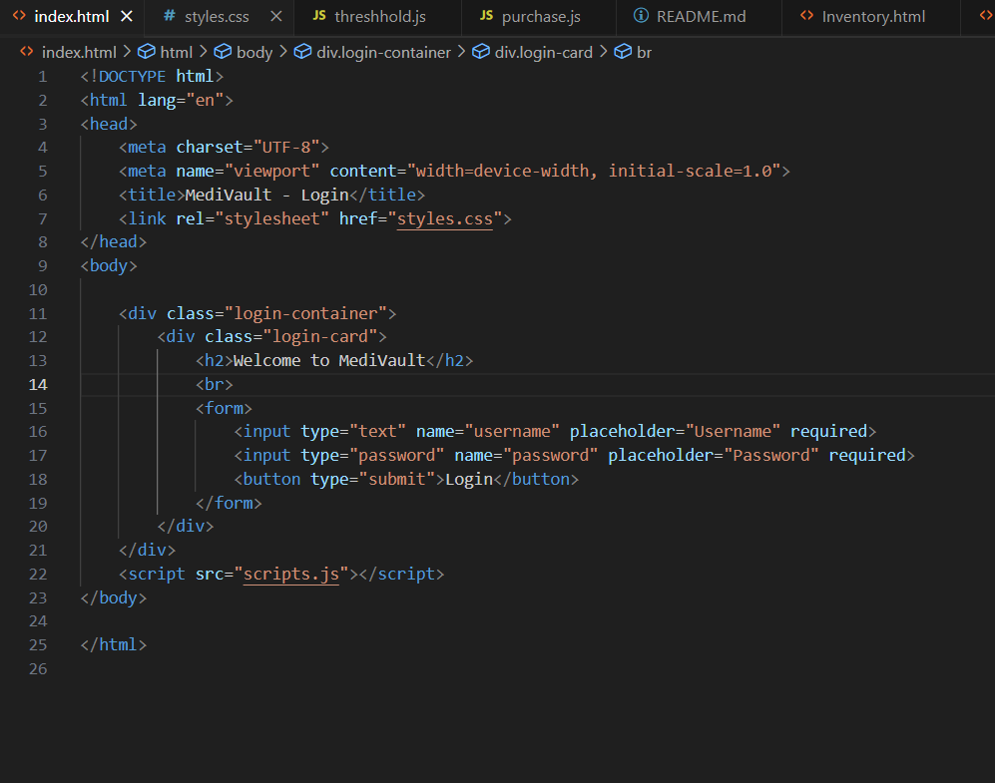
Figure 3.1 – Shows the Login page code

Dashboard –
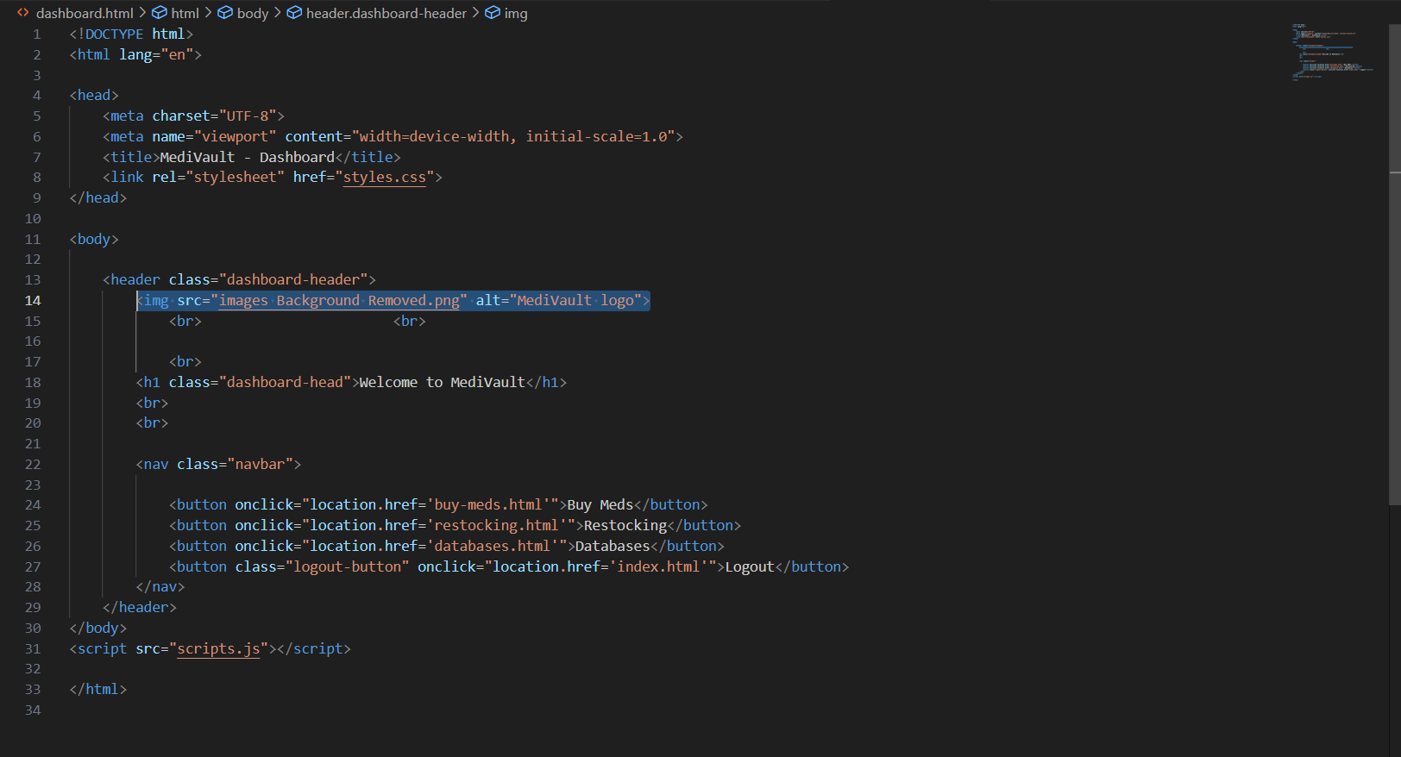
Figure 3.2 – Shows the dashboard code

Buy-meds Page –
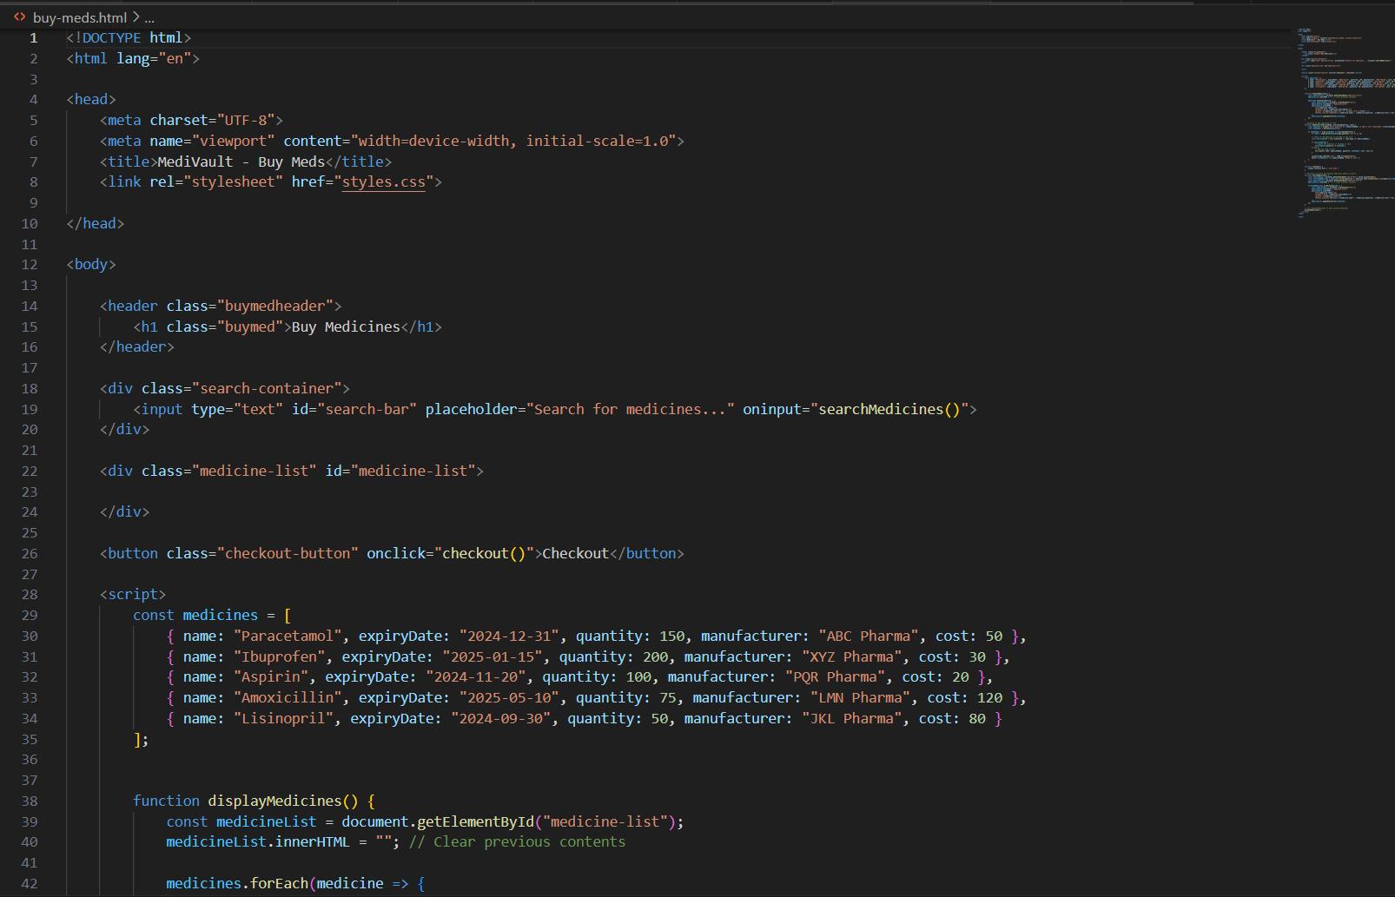
Figure 3.3.1 - Shows the Buy-meds page code
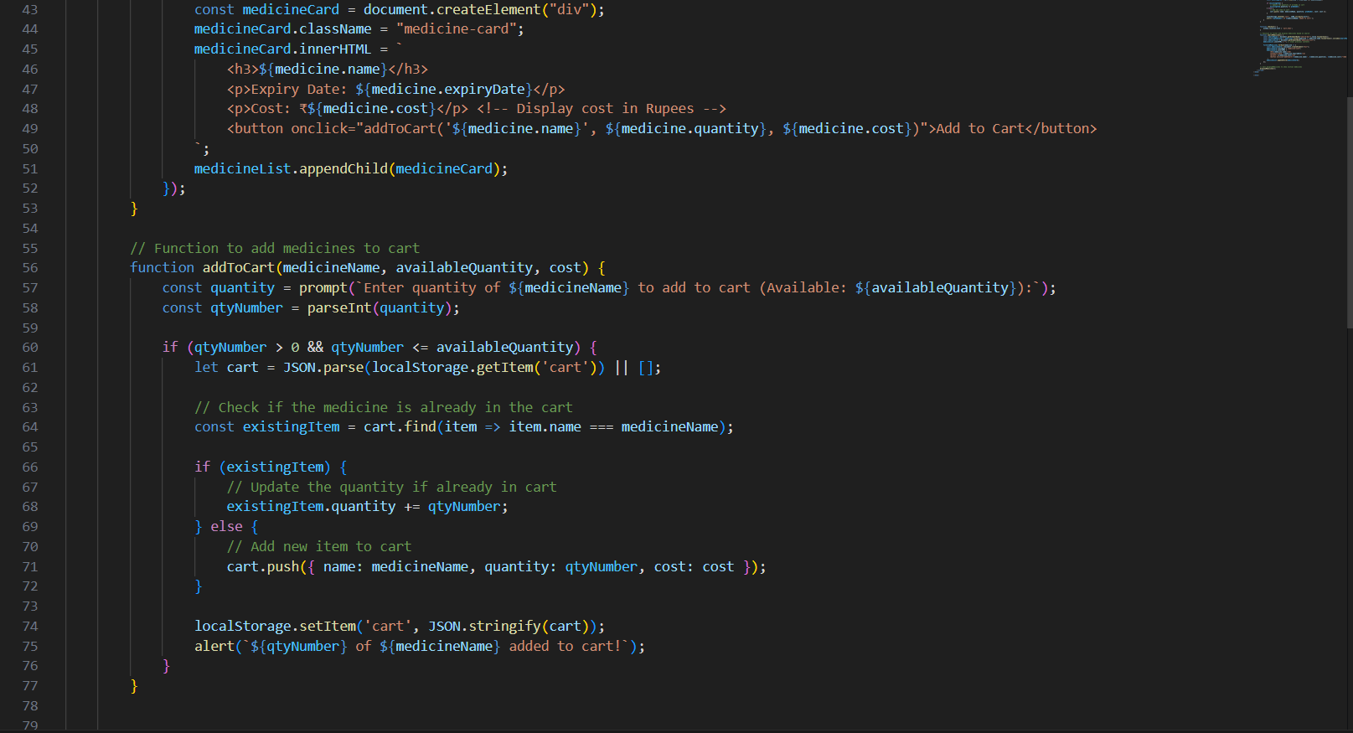
Figure 3.3.2 - Shows the Buy-meds page code
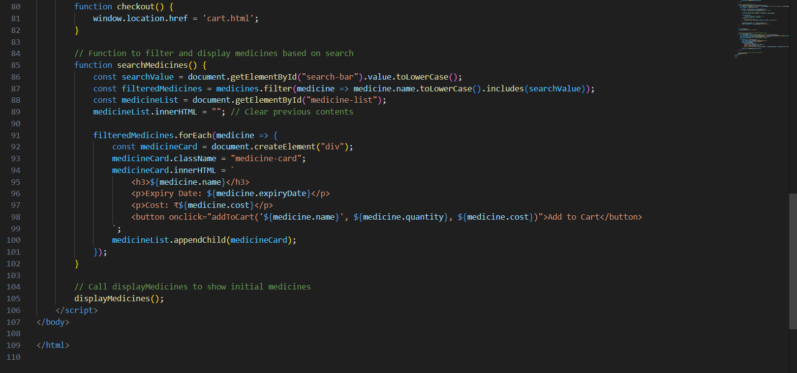
Figure 3.3.3 - Shows the Buy-meds page code

Cart Page –
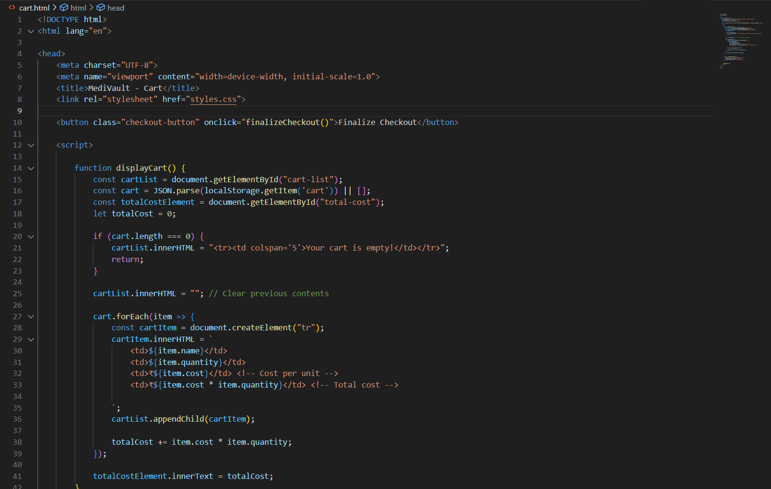
Figure 3.4.1 – Shows the Cart page code
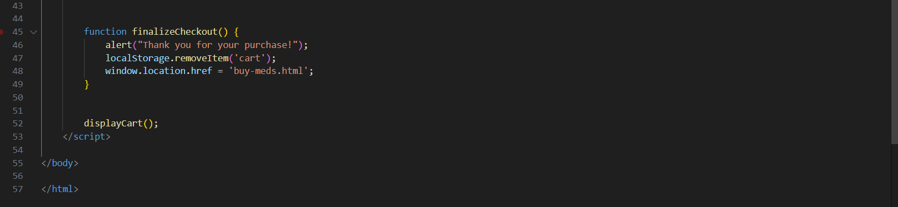
Figure 3.4.2 – Shows the Cart page code

The Javascript page for the functionality of login page and basic buying medicines and checking out from the cart –
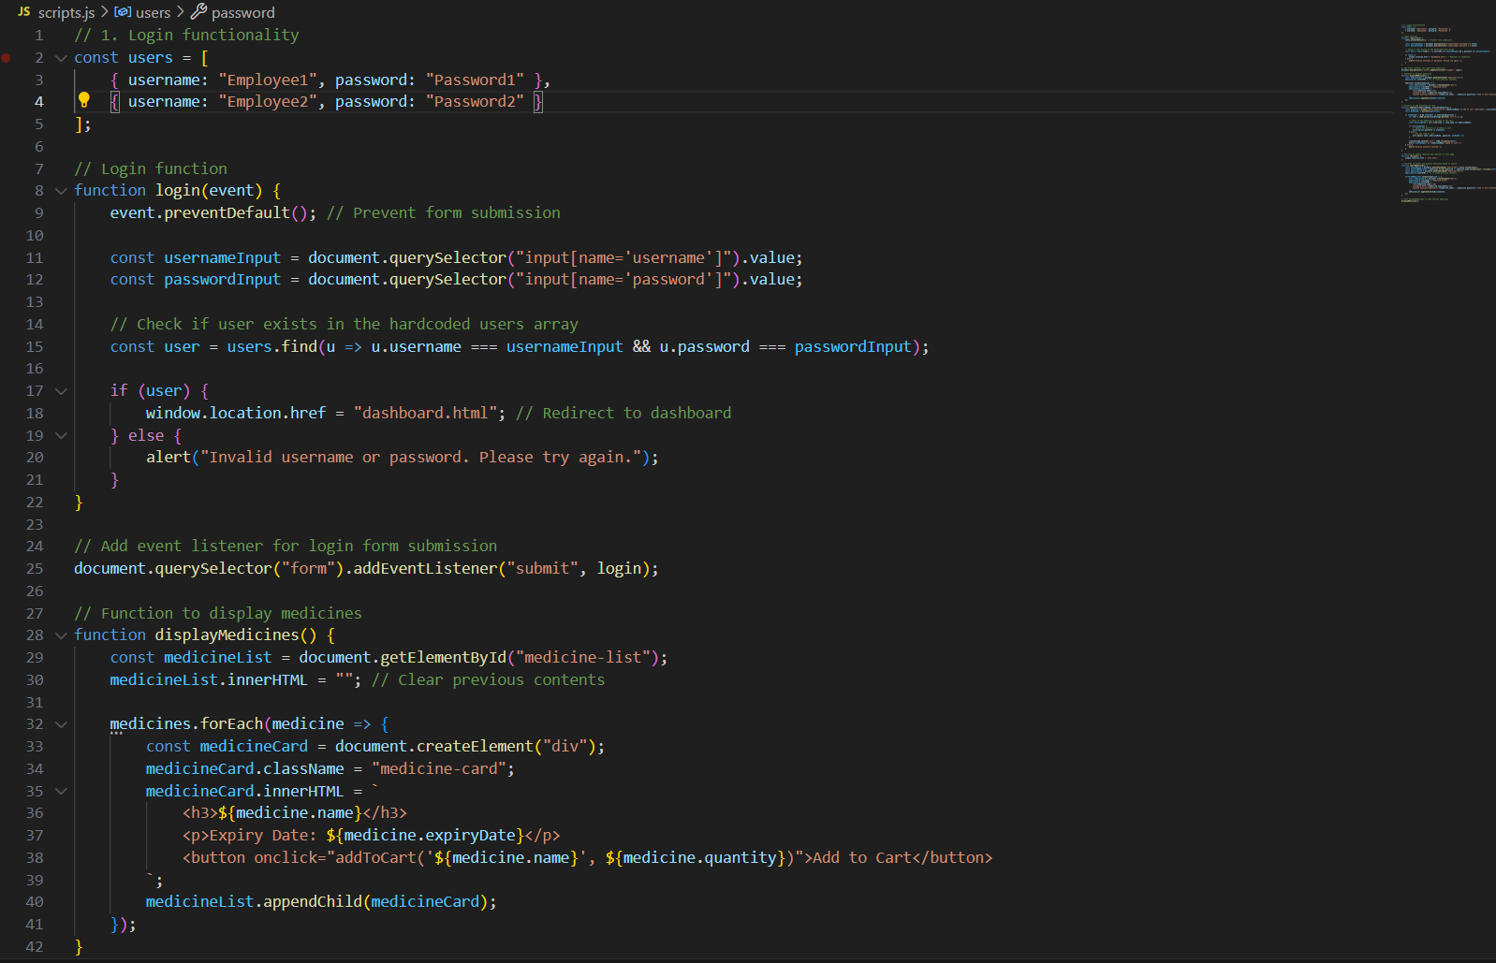
Figure 3.5.1 – Shows the JavaScript Code
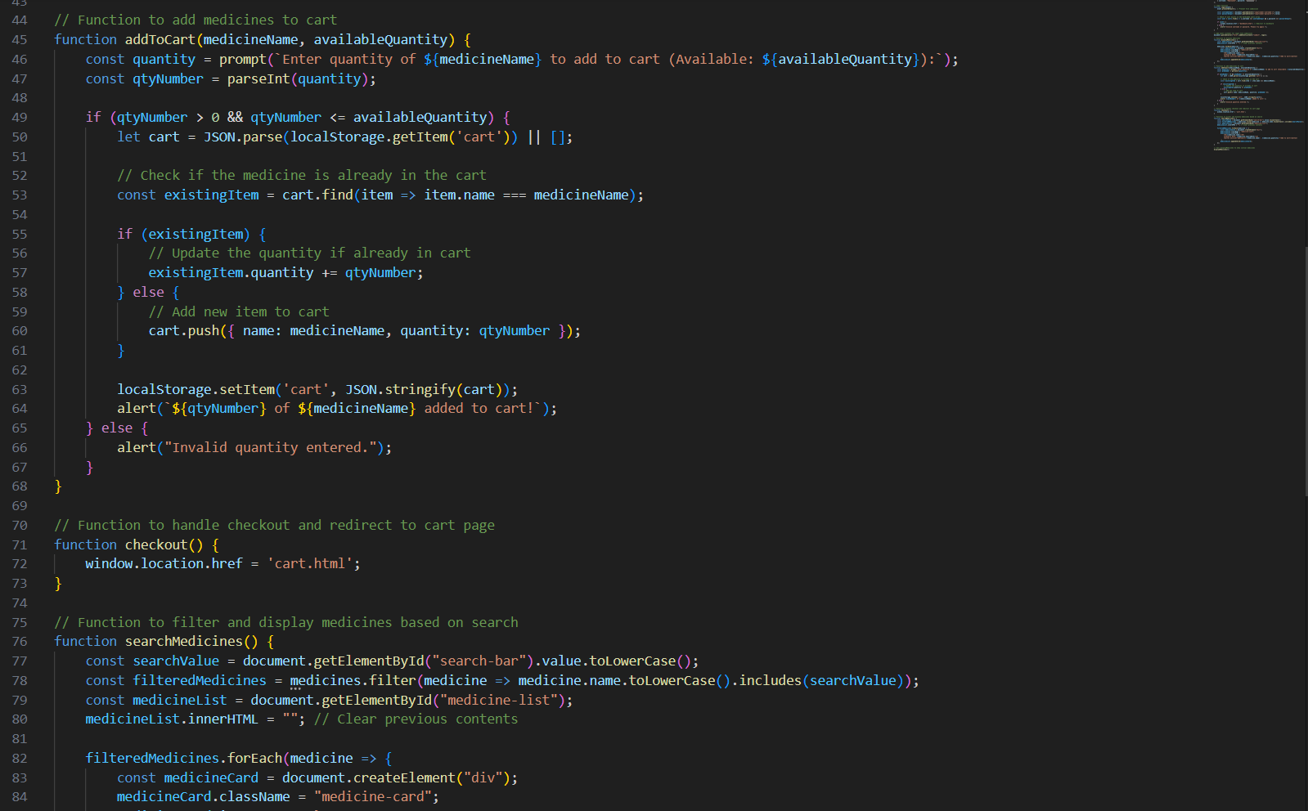
Figure 3.5.2 - Shows the JavaScript Code
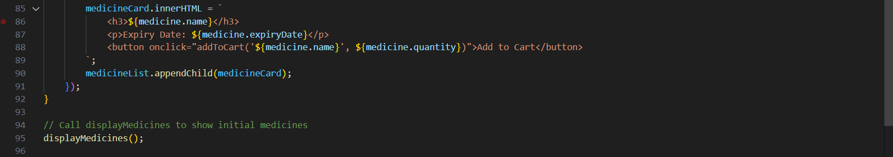
Figure 3.5.3 - Shows the JavaScript Code

Code for Restocking functionality –
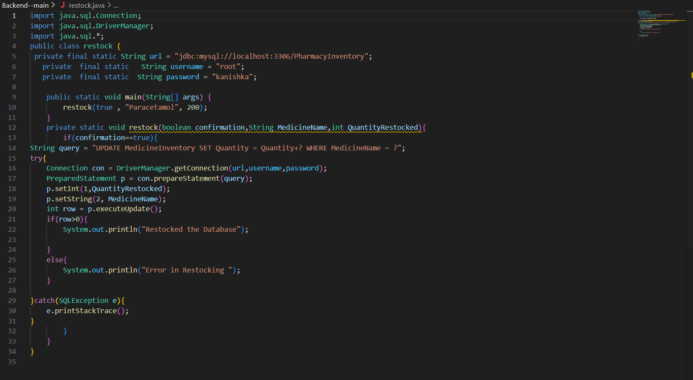
Figure 3.6 – Shows the code for Restocking functionality

Code for sending an email to restock the medicine –
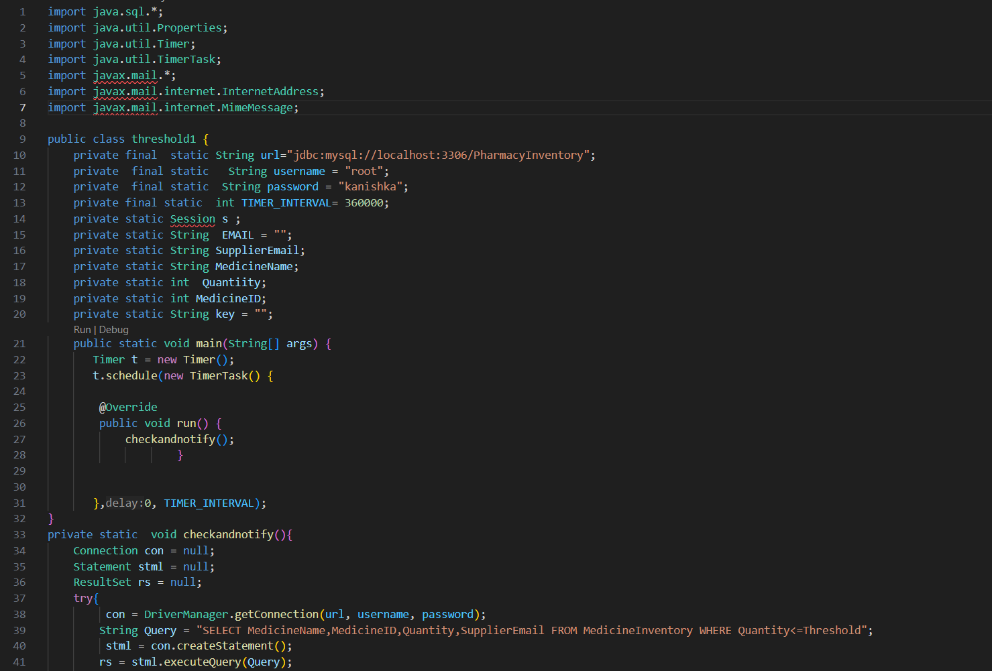
Figure 3.7.1 – Shows the code for sending the required email.
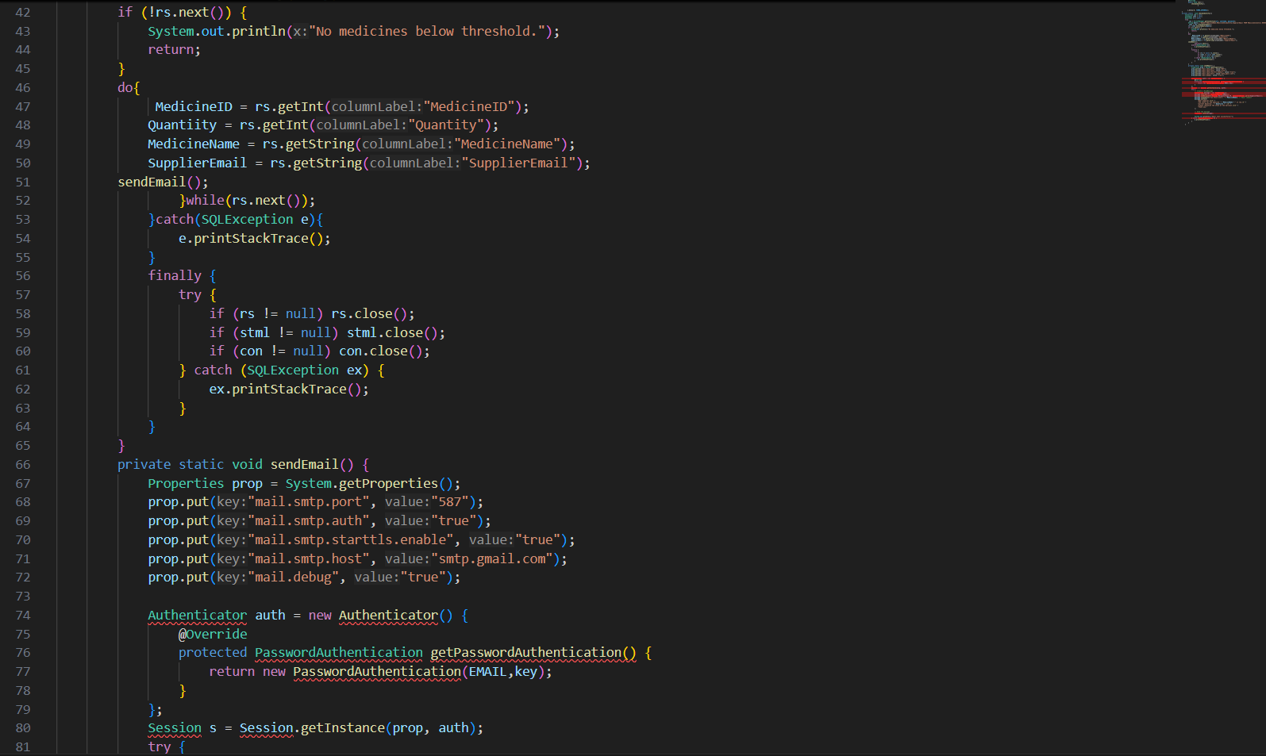
Figure 3.7.2 - Shows the code for sending the required email.
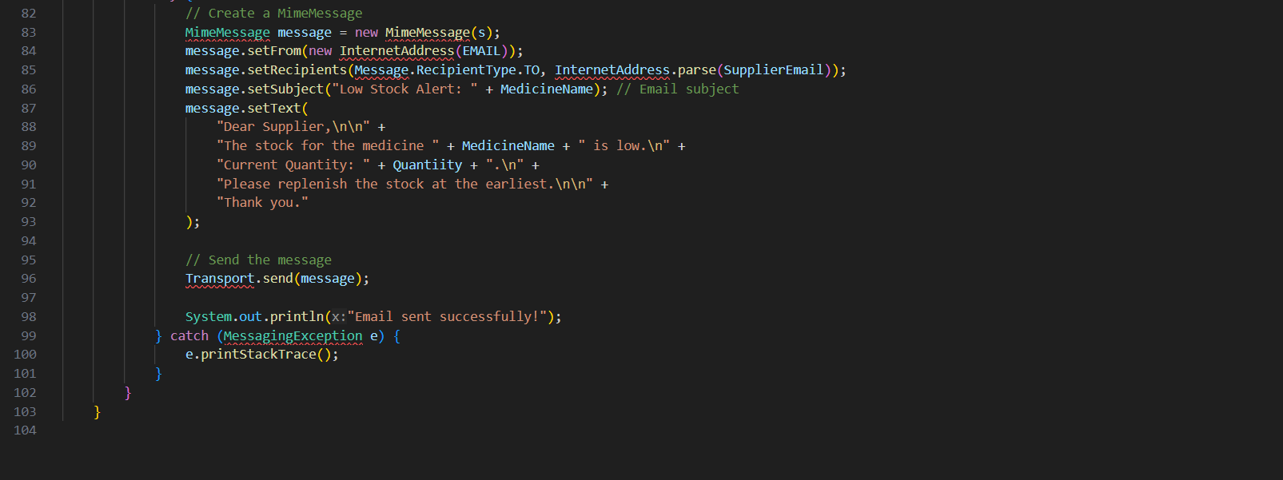
Figure 3.7.3 - Shows the code for sending the required email.

REFERENCE
[1] - Refonaa, J., SL Jany Shabu, Kg Dion Paul, S. Dhamodaran, and Viji Amutha Mary. "MediStock: Medical Inventory Management System." In 2023 4th International Conference on Electronics and Sustainable Communication Systems (ICESC), pp. 738-743. IEEE, 2023.
[2] - Saha, Esha, and Pradip Kumar Ray. "Patient condition-based medicine inventory management in healthcare systems." IISE Transactions on Healthcare Systems Engineering 9, no. 3 (2019): 299-312.
[3] - Kritchanchai, Duangpun, and Watcharaphong Meesamut. "Developing inventory management in hospital." International Journal of Supply Chain Management 4, no. 2 (2015): 11-19.
[4] - Zakas, Nicholas C. Professional JavaScript for Web Developers. John Wiley & Sons, 2005.
[5] - Zhou, Wei, Li Li, Min Luo, and Wu Chou. "REST API design patterns for SDN northbound API." In 2014 28th international conference on advanced information networking and applications workshops, pp. 358-365. IEEE, 2014.
[6]- Serrano, Diego, Eleni Stroulia, Diana Lau, and Tinny Ng. "Linked REST APIs: a middleware for semantic REST API integration." In 2017 IEEE International Conference on Web Services (ICWS), pp. 138-145. IEEE, 2017.
[7] - Monteiro, Fernando. Hands-On Full Stack Web Development with Angular 6 and Laravel 5: Become fluent in both frontend and backend web development with Docker, Angular and Laravel. Packt Publishing Ltd, 2018.
[8] - Dutta, S., K. Feige, K. Rink, and B. Nsonga. "A Flexible Architecture for Web-based GIS Applications using Docker and Graph Databases." (2024).
[9] - Annanias, Yves, and Daniel Wiegreffe. "A Flexible Architecture for Web-based GIS Applications using Docker and Graph Databases." arXiv preprint arXiv:2404.12074 (2024).
[10] - Choma, Dominik, Kinga Chwaleba, and Mariusz Dzieńkowski. "The efficiency and reliability of backend technologies: Express, Django, and Spring Boot." Informatyka, Automatyka, Pomiary w Gospodarce i Ochronie Środowiska 13 (2023).
[11] - Rajput, Ajeet Singh, Harsh Pratap Singh, Garima Bang, Shelley Joshi, and Trapti Patidar. "Comparing Spring Boot and ReactJS with Other Web Development Frameworks: A Study." In International Conference on Data Science and Applications, pp. 149-160. Singapore: Springer Nature Singapore, 2023.
[14] - Nadon, Jason. Website Hosting and Migration with Amazon Web Services: A Practical Guide to Moving Your Website to AWS. Apress, 2017.
[15]- Sarkar, Aurobindo, and Amit Shah. Learning AWS: Design, build, and deploy responsive applications using AWS Cloud components. Packt Publishing Ltd, 2018.

